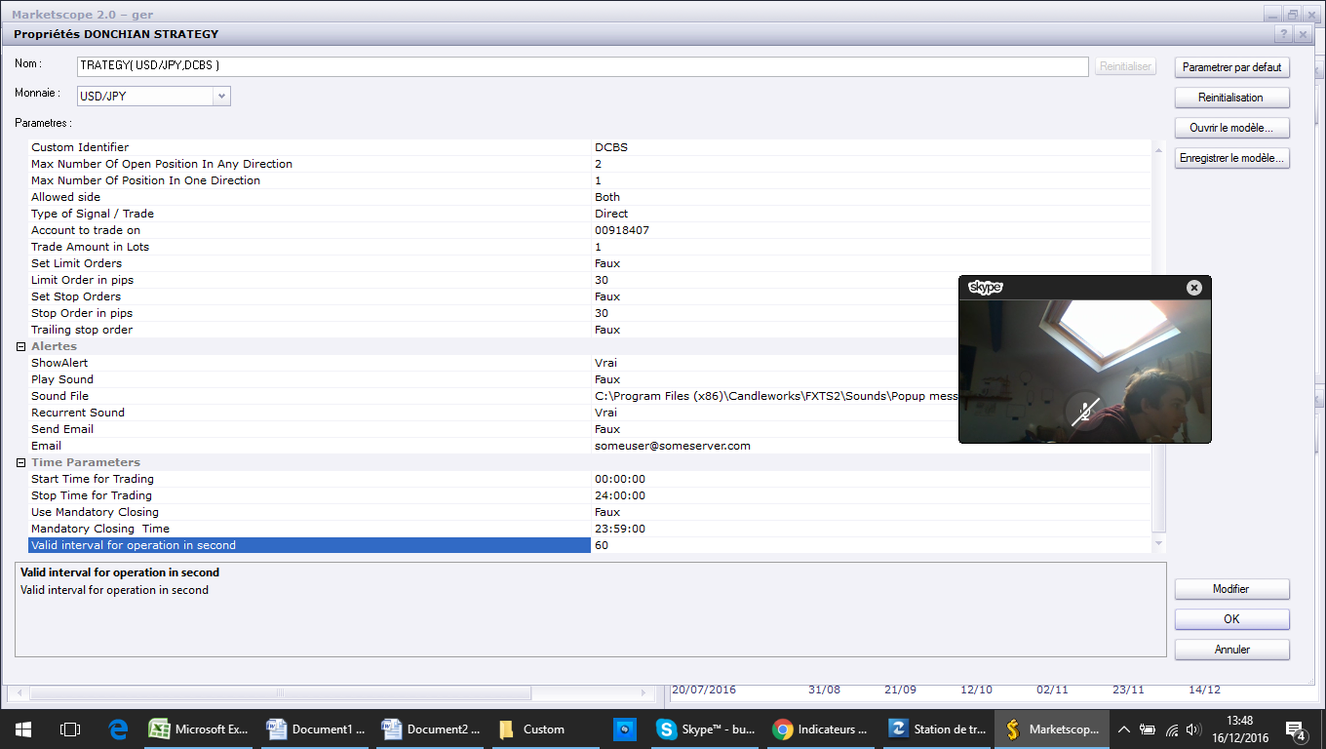
Figure 1 Can you add: Custom identifier

